Wenham Village Improvement Society
Education Scholarship Application
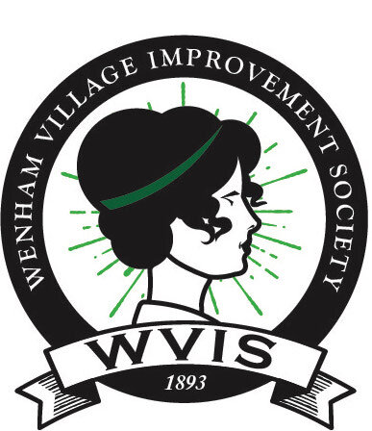

The Wenham Village Improvement Society (WVIS) is a philanthropic organization that works to benefit the community providing recreational, social and educational programs to the residents of Wenham.
For 2024, the WVIS is excited to offer five $2000 scholarships to students of the Town of Wenham who can demonstrate their enthusiasm for the Town of Wenham and/ either their educational goals or their community service.

Requirements for eligibility:
- The applicant must be a Wenham resident who is pursuing or enrolled in post-secondary education.
- The applicant must not have previously been awarded a WVIS scholarship
- The application must be completed by the applicant themselves and signed by the student and a parent or guardian even if the applicant is over 18

Awards will be made in May during the HWRSD scholarship night.

The application must be submitted in full by the deadline: April 1st
NO exceptions will be accepted.

Please email the completed application to us at wenhamvis@gmail.com Once received, a confirmation email will be sent.
WVIS Application Identification Page

The purpose of this page is identification. The Scholarship Committee will not have access to this page. When we receive the application, it will be assigned a number. This will enable us to ensure objectivity in our selection process.
DO NOT TO WRITE YOUR NAME ON ANY OTHER PAGE

Date of Application: _________________________________

Your Name: _________________________________

Home Address: _________________________________

Telephone Number: _________________________________

Date of Birth: _________________________________

Email Address: _________________________________

Parent/Guardian’s Name (s:) ____________________________

Is your family a WVIS Member ? Yes _______ No ________ Ineligible _______

We declare that the information reported in this application, to the best of our knowledge, is true and correct.
We, hereby declare that the content of this scholarship application has been created solely by the applicant, without the use of any artificial intelligence (AI) or machine learning tools.

_____________________________ _________________________________
Signature of Applicant Signature of Parent/Guardian

WVIS IS A PHILANTHROPIC ORGANIZATION THAT WORKS TO BENEFIT THE COMMUNITY BY PROVIDING RECREATIONAL, SOCIAL AND EDUCATIONAL PROGRAMS TO RESIDENTS OF WENHAM.

Essays
Please limit your responses to no more than 1 page each. You must complete both essays for your application to be complete.

Essay #1: Write about a favorite location in the Town of Wenham. What makes it your favorite? What significance does this location play in building the community?

Essay #2: Answer JUST ONE of the questions below.

- Describe a community service experience you organized or helped lead. The project should have been completed in the last 2 years. Describe your role, the group served, and what you learned from the project.
OR
- Describe your educational goals. What do you wish to study and why?

Short Answer
Please list extra-curricular activities, civic activities, and internships including dates of participation and/or list any paid work experience and include your responsibilities, dates, and hours worked. _____________________________________________________________________________
_____________________________________________________________________________
_____________________________________________________________________________
_____________________________________________________________________________
_____________________________________________________________________________
_____________________________________________________________________________

Please provide information about your current academic standing.
What year of study are you currently in? ___________________
Will you be attending full-time or part-time? ________________

Thank you for applying.

We wish you only the best for your future.

